EVALUATION OF SOME POTENTIAL NIGERIA TREES AND THEIR EXTRACTS FOR ORGANIC COSMETIC PRODUCTION
Shuaibu, R. B.¹ and Salami, K. D.²^{, 3}
¹Department of Forestry and Wildlife Management, Federal University Dutsin-Ma
² Department of Forestry and Wildlife Management, Federal University Dutse, Dutse, Jigawa State, Nigeria
³Forest Ecology and Conservation Unit, Center for Arid Zone Ecology, Federal University Dutse, Jigawa State, Nigeria
Corresponding author email: foristsalam@yahoo.com; 07034294371

Abstract
Chemicals such as hydroquinone, mercury, lead and arsenic are used for treating skin issues, bleaching and ﬁrming up the skin but their damaging, degenerative and toxicity effects on the skin tissues has resulted in more harm than good. Extracts of a wide variety of trees are non-toxic and hypoallergenic, they are natural antioxidants, anti-ageing, anti-inflammatory, anti-septic, anti-microbial, anti-fungal, anti-bacteria, anti-viral, anti-parasitic, as a sunscreen, and stimulate the production of collagen, and are better alternative to the inorganic chemicals in cosmetics. This study assessed the cosmetic potentials of the extracts of various tree species which are common in Nigeria and the implication on forestry practices in Nigeria. Eighteen tree species’ extracts found within Nigeria were collected and incorporated into soap and cream productions. The tree species includes Acacia nilotica, Adansonia digitata, Azadirachta indica, Baphia nitida, Camellia sinensis, Cinnamomum camphora, Cinnamomum verum, Elaeis guineensis, Eucalyptus camadulensis, Vitellaria paradoxa, Zizphus spina-christ and others. A comparative analysis before and after using the soaps and creams produced to treat twenty selected individuals with different skin issues for three to six months were carried out to determine the efficacy of the products. The result shows that there was a significant change in all the skin issues ranging from pimples, acne, blemishes, sun tan, sores, shaving bumps, eczema, psoriasis, warts, wounds, body odour and head issues such as dandruff, bald head, and sore scalp after three months of usage. There was a total cure after six months of usage. Therefore, the cosmetic industries should be encouraged into forestry practices by converting large area of bare land into forest with different species of trees needed for their cosmetic production.
Keywords: Evaluation, Nigeria Trees, Tree Extracts, Organic Cosmetic, Production
INTRODUCTION
The use of tree derived ingredients such as the bark, leaves, fruits, seeds, and root extracts in organic cosmetic formulation is increasing because of its beauty and medicinal benefits which include cleansing properties, treating blemishes and controlling oil, moisturizing, cooling, skin lightening and brightening, as a sunscreen, as a perfume or aromatic, anti-fungal, anti-bacteria, anti-viral, anti-inflammatory and anti-ageing properties. The environment has offered powerful ingredients for natural cosmetics, whereas science and technology helped to uncover and better understand their action (Greta, 2020). Organic Cosmetic Products can be defined as the formulation such as soap, cream, shampoo, and perfume for external surface application of the human body using tree and plant extracts. According to Dweck. (1996), the consumer products (Safety) Regulations 1989 refers to cosmetic product as ‘any substance or preparation intended for application to any external surface of the human body (that is to say, epidermis, hair system, nails, lips and external genital organs), to the teeth, buccal mucosa wholly, or mainly for the purpose of cleaning, perfuming, protecting them, or keeping them in good condition or changing their appearance or combating body odor or perspiration except where such cleaning, perfuming, protecting, keeping, changing or combating is wholly for the purpose of treating or preventing disease.
The contribution of tree and plant extracts to cosmetic products can clearly go beyond the isolation of bioactive compounds. Plants have offered innovative solutions to medicine, material science, architecture, robotics, and engineering and can surely further cosmetic products (Momeni and Ni, 2018). Plant extracts exhibit moisturizing, nourishing, capillary-stabilizing, cleansing, anti-inflammatory, antimicrobial, emollient, melanin-inhibiting, antimutagenic, astringent, regenerating and UV-protective properties (Michalak, 2022). Organic cosmetics as products whose efficacy is ascribed to their tree and plant derived ingredients have been used for centuries for treating skin conditions and a wide variety of dermatological disorders, including inﬂammation, photo-toxicity, psoriasis, atopic dermatitis and alopecia areata. The use of the natural alternatives may impact the cost-effectiveness of the final product, whereas their use in combination with existing filters may be more feasible and their action could be exploited as boosters (Greta, 2020).
Morphological alterations of the skin are due to changes due to aging in the skin, in which degenerative changes exceed regenerative changes, such as thinning and wrinkling of the epidermis, the appearance of lines, creases, crevices and furrows, the loss of collagen and elastin ﬁbres, with lessened support of epidermal layers, and lessened circulatory perfusion. Considering the microbiome and how important a balance with the skin is, the mechanisms that plants have evolved against pathogens and based on proteins, peptides, and small molecules will offer new strategies, also when looking for alternative preservation strategies (Tiku, 2020). There are natural or chronological ageing processes that occur with the passage of time and are the product of the cellular oxidative stress of the organism (Francisco and Luis, 2018). Accelerated ageing is caused by various environmental factors: ultraviolet (UV) radiation, electromagnetic ﬁelds, chemicals, and climatology (Francisco and Luis, 2018). In these cases, reactive oxygen species (ROS) are produced and damage DNA telomeres, enzymes, and cell membranes (González et al., 2008). These and other considerations are fundamental for understanding the present and the future of skin and beauty products (Francisco and Luis, 2018). It is no longer enough to look good, it is also vital to delay ageing and prevent the appearance of illness (Francisco and Luis, 2018). True ‘antiaging’ actions would require evidence for the reversal of the regenerative/degenerative balance, exempliﬁed by increased collagen and elastin synthesis, thereby restoring toward normal the regenerative/degenerative equilibrium (Aburjai and Natsheh, 2003).
The skin is a protective layer and a sensing structure of the body. Skin faces environmental and internal stressors that impact its integrity and has evolved molecular coping mechanisms (França et al., 2017). The skin is the largest organ of our body, and when it is in a compromised state our quality of life is affected. Skin has a tightly regulated circadian rhythm and its activities change day and night (Wu et al., 2018). Also, each cell of the skin can respond differently to stressors over time and behave differently from its surrounding resulting in a very heterogeneous tissue. For example, of all the fibroblasts that are responsible for the generation of the connective tissue in our skin, only some of them produce inflammatory molecules affecting the surrounding cells and promoting the skin aging (Mahmoudi et al., 2019).
The growing awareness that we are responsible for the world in which we live and on the increasing concern for one’s own health has resulted in the trend of organic cosmetics from forest tree extracts within our localities. Nigeria as one of the tropical rainforest country is blessed with abundant tree species which can be used in organic or natural cosmetic formulations. According to Caesar et al. (2017), those countries leading in the development of natural cosmetics includes China, South Korea, and Japan, with France being the most active at the European level, at least according to their fervent patent activity on anti-cellulite, tanning, or whitening cosmetics. There are big opportunities for Nigeria to expand its herbal and organic cosmetics productions through its unique abundance of forest tree species with traditional knowledge of the indigenous people on how to incorporate the tree extracts into cosmetics. The skin due to excessive exposure to harsh weathers, microbes, chemical agents, biological toxin present in the environment will dehydrate and causes wrinkle, freckles, blemishes, pigmentation and sunburns. Dangerous chemicals such as hydroquinone, mercury, lead, and arsenic were used for bleaching and ﬁrming up the skin for a very long time until they were banned due to their damaging, degenerative and toxicity effects on the skin tissues. Extracts of a wide variety of forest trees are non-toxic and hypoallergenic, they are natural antioxidants, anti-ageing, anti-inflammatory, anti-septic, anti-microbial, anti-fungal, anti-bacteria, anti-viral, anti-parasitic, as a sunscreen, and stimulate the production of collagen. The assessment of incorporation of forest tree derived ingredients with activity against various skin conditions into cosmetic formulation especially soap and cream are imperative. The objective of this study is to assess the cosmetic potentials of the extracts of various tree species which are common in Nigeria and the implication on forestry practices in Nigeria.
MATERIALS AND METHODS
Study Area
Nigeria is a country in West Africa, it lies within the tropics along the Gulf of Guinea, on the west coast of Africa. Nigeria is located between Latitudes 4°N and 14°N of the equator and between longitude 3°E and 15°E of the Greenwich meridian. It has a total land area of approximately 923,768km² (Wikipedia) with a population of 206,760,319 (United Nation, 2020). Nigeria is bounded by Benin Republic on the South-West region, Cameroun on the South-East region, Niger Republic on the North-West region, Chad Republic on the North-East region, and Atlantic Ocean to the South-South region. Nigeria has 36 states and 774 LGAs with Abuja as the Federal Capital city.
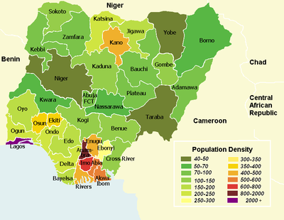
Source: Wikipedia.
Fig 1: Showing the map of Nigeria
Data Collection Method
Data were collected from Eighteen (18) selected forest tree species found within Nigeria. The species includes Acacia nilotica, Adansonia digitata, Azadirachta indica, Baphia nitida, Camellia sinensis, Cinnamomum camphora, Cinnamomum verum, Cocos nucifera, Elaeis guineensis, Eucalyptus camadulensis, Moringa oleifera, Olea europaea, Pinus sylvestris, Prosopis africana, Salix babylonica, Theobroma cacao, Vitellaria paradoxa, and Zizphus spina-christ. Their extracts which includes the leaves, the bark, the seeds, the pods, the wood, and the roots were collected. The leaves were dried and grinded into powder form, the seeds were dried and oils were extracted from them, the bark were dried and grinded into powder form, the powder from the pod were collected, the wood were dried and grinded into powder form, and the root were dried and grinded into powder form.
Method of Incorporating the Tree Extracts into Soap and Cream Productions
Extracts of the selected forest tree species for this research were incorporated into soap and cream productions as follows: All the oils from the seeds of the tree species in this study were used as the base oil for saponification process of the soap production and the base oil for the cream productions. i) Azadirachta indica extracts: the powder from the grinded dried leaves were added to the soap at the gel phase. ii) Willow tree (Salix babylonica) extracts: the bark and the leaves were boiled and the collected boiled water was used to make the solution of Sodium hydroxide for soap making and part of the collected boiled water was also used as the base water for cream production. iii) Drum stick tree (Moringa oleifera) extracts: the powder from the grinded dried leaves were added to the soap at the gel phase. iv) Baobab Tree (Adansonia digitata) extracts: the white powder from the pod were added to the gel phase of soap and liquid phase of cream making. v) Camwood tree or African Sandal wood (Baphia nitida) extracts: the powder from the grinded wood were added to the gel phase of soap making. vi) Camphor tree (Cinnamomum camphora) extract: the powder from dried leaves were added to the gel phase of soap making. vii) Cinnamon tree (Cinnamomum verum) extract: the powder from the grinded bark were added to the gel phase of soap making. viii) Lote Tree (Zizphus spina-christ) extracts: the powder from the grinded dried leaves and roots were added to the gel phase of soap making and the water used in boiling the bark were used to make the solution of Sodium hydroxide. ix) Gum arabic tree (Acacia nilotica) extracts: the oil from the seed was added to other oils for saponification process of soap making and base oil for cream making. x) Shea butter tree (Vitellaria paradoxa) extract: the oil from the seeds was used. xi) Olive Tree (Olea europaea) extract: the oil from the seeds was used. xii) Coconut palm tree (Cocos nucifera) extracts: the milk from the flesh were added to the gel phase of soap making. xiii) Palm oil tree (Elaeis guineensis) extracts: the oil from the fruit pulp and kernel were used. xiv) Pine tree (Pinus sylvestris) extract: the oil derived from the steam distillation of pine needles was used. xv) Tea tree (Camellia sinensis) extract: the oil was used. xvi) River red gum tree (Eucalyptus camadulensis) extract: the powder from dried leaves and seed oil were incorporated. xvii) Coco tree (Theobroma cacao) extract: the butter was used. xviii) Iron tree (Prosopis africana) extracts: the charcoal produce from the burnt wood was added to the gel phase of soap making.
The extracts were divided into three units. The first unit was the mixture of Zizphus spina-christ, Olea europaea, and Elaeis guineensis extracts incorporated into the soap and cream. The second unit was the mixture of Azadirachta indica, Salix babylonica, Baphia nitida, Cinnamomum camphora, Cocos nucifera, Elaeis guineensis, Pinus sylvestris, Camellia sinensis, Eucalyptus camadulensis, Prosopis africana extracts incorporated into the soap and cream. The third was the mixture of Moringa oleifera, Adansonia digitata, Theobroma cacao extracts, Cinnamomum verum, Acacia nilotica, Elaeis guineensis, Vitellaria paradoxa, and Olea europaea extracts incorporated into the soap and cream.
Data analysis
A comparative analysis before and after using the soaps and creams to treat twenty (20) selected individuals with different skin issues and those without skin issues (five persons with pimples, acne, and skin blemishes; two persons with extremely dry skin; three persons with sun burn and sun tan; two persons with eczema and psoriasis; one person with dandruff, lies, and sore scalp; two persons shaving bumps and wounds; one person with warts; and four persons with no skin issues but with serious body odour) were carried out to determine the efficacy of the products. The first mixture of soap was used for all the twenty individuals for three months; the second mixture was used for all the twenty individuals for three months; and the third was also used for the twenty individuals for three months.
RESULTS
Extracts of eighteen (18) different forest tree species, twelve (12) families, twelve (12) orders, and One (1) kingdom found within Nigeria were collected and incorporated into soap and cream productions. Table 1 showed the list of forest trees incorporated into the soap and cream productions. Table 2 shows the extracts of tree used in the productions. Three sets of soap and cream were produce from different mixtures of the tree extracts. Figure 2 shows the three (3) sets of soap produced and figure 3 shows the three (3) sets of cream produced.
The results of the first set produced (Zizphus spina-christ, Olea europaea, and Elaeis guineensis extracts incorporated into the soap and cream) which was used by twenty (20) individuals (five persons with pimples, acne, and skin blemishes; two persons with extremely dry skin; three persons with sun burn and sun tan; two persons with eczema and psoriasis; one person with dandruff, lies, and sores; two persons shaving bumps and wounds; one person with warts; one person with skin rashes; and three persons with no skin issues but with serious body odour) for three months shows that those individuals with dandruff, lies, sores; shaving bumps, wounds and skin rashes were completely cured. There was also a noticeable change from those having other skin issues, and there was a significant change in the skin texture. There was a report from two (2) persons who claimed to have Jin and witchcraft attack and other negative forces around them that there was a positive change while using the Sidr and Olive extracts soap and cream. The Jin attack completely stopped and night mares they were having also stopped.
The results of the second set produced (Azadirachta indica, Salix babylonica, Baphia nitida, Cinnamomum camphora, Cocos nucifera, Elaeis guineensis, Pinus sylvestris, Camellia sinensis, Eucalyptus camadulensis, and Prosopis africana extracts incorporated into the soap and cream) which was used by twenty (20) individuals (five persons with pimples, acne, and skin blemishes; two persons with extremely dry skin, wrinkles and fine lines; three persons with sun burn and sun tan; two persons with eczema and psoriasis; one person with dandruff, lies, and sore scalp; two persons shaving bumps and wounds; one person with warts; and four persons with no skin issues but with serious body odour) for three months shows that almost all the skin issues ranging from pimples, acne, blemishes, sun tan, and body odour completely disappeared. There was a noticeable change in their skin texture and complexion. There was a reduction in the appearance of wrinkles and fine lines. Smooth and glowing skin with even toned and bright complexion was significantly noticed.
The results of the third set produced (Moringa oleifera, Adansonia digitata, Theobroma cacao, Cinnamomum verum, Acacia nilotica, Elaeis guineensis, Vitellaria paradoxa, and Olea europaea extracts incorporated into the soap and cream) which was used by twenty (20) individuals (five persons with pimples, acne, and skin blemishes; two persons with extremely dry skin, wrinkles and fine lines; three persons with sun burn and sun tan; two persons with eczema and psoriasis; one person with dandruff, lies, and sore scalp; two persons shaving bumps and wounds; one person with warts; and four persons with no skin issues but with serious body odour) for three months shows that there was a significant changes in those with dry skin, wrinkles, and fine lines. Their skin regained smooth texture free from wrinkles and fine lines with glowing appearance. Figure 4 shows the pictures of before and after three months of applications of all the products.

Table 1: The List of Tree Species Incorporated into the Soaps and Cream Production
Tree Species | Common Names | Family | Order | Kingdom
Acacia nilotica | gum arabic tree | Fabaceae | Fabales | Plantae
Adansonia digitate | Baobab | Malvaceae | Malvales | Plantae
Azadirachta indica | Neem tree | Meliaceae | Sapindales | Plantae
Baphia nitida | African Sandal wood | Fabaceae | Fabales | Plantae
Camellia sinensis | Tea tree | Theaceae | Ericales | Plantae
Cinnamomum camphora | Camphor tree | Lauraceae | Laurales | Plantae
Cinnamomum verum | Cinnamon tree | Lauraceae | Laurales | Plantae
Cocos nucifera | Coconut palm tree | Arecaceae | Arecales | Plantae
Elaeis guineensis | Palm oil tree | Arecaceae | Arecales | Plantae
Eucalyptus camadulensis | African red gum tree | Malvaceae | Myrtales | Plantae
Moringa oleifera | Drum stick tree | Moringaceae | Brassicales | Plantae
Olea europaea | Olive Tree | Oleaceae | Lamiales | Plantae
Pinus sylvestris | Pine tree | Pinaceae | Pinales | Plantae
Prosopis africana | Iron tree | Fabaceae | Fabales | Plantae
Salix babylonica | Weeping Willow tree | Salicaceae | Malpighiales | Plantae
Theobroma cacao | Coco tree | Malvaceae | Malvales | Plantae
Vitellaria paradoxa | Shea butter tree | Sapotaceae | Ericales | Plantae
Zizphus spina-christ | Lote Tree/Christ's thorn | Rhamnaceae | Rosales | Plantae
Source: Author’s Field Survey, (2022)

Table 2: The Parts of Tree Extracts used in the Productions
S/N | Tree Species | Part used for Soap | Part used for Cream
1 | Acacia nilotica | oil from the seed | Oil from the seed
2 | Adansonia digitata | Powder from the Pod | Seed Oil & Powder
3 | Azadirachta indica | Dried Leaves Powder | Seed Oil
4 | Baphia nitida | Wood Powder | Oil distilled from the wood
5 | Camellia sinensis | Oil | Oil
6 | Cinnamomum camphora | Dried Leaves Powder | Oil distilled from the wood
7 | Cinnamomum verum | Bark Powder | Oil infused from bark powder
8 | Cocos nucifera | Nut Flesh Milk | Nut Flesh Oil
9 | Elaeis guineensis | Oil from the fruit pulp & kernel | Oils from the Kernel
10 | Eucalyptus camadulensis | Dried Leaves Powder | Oil
11 | Moringa oleifera | Dried Leaves Powder | Seed oil
12 | Olea europaea | Oil | Oil
13 | Pinus sylvestris | Oil distilled from the Needles | Oil distilled from the Needles
14 | Prosopis africana | Charcoal from the burnt wood | Nil
15 | Salix babylonica | Water from the bark | Water from the bark
16 | Theobroma cacao | The butter from the Seed | The butter from the Seed
17 | Vitellaria paradoxa | Oil from the Seed | Oil from the Seed
18 | Zizphus spina-christ | Dried Leaves Powder | Dried leaves water & seed oil
Source: Author’s Work, (2022)

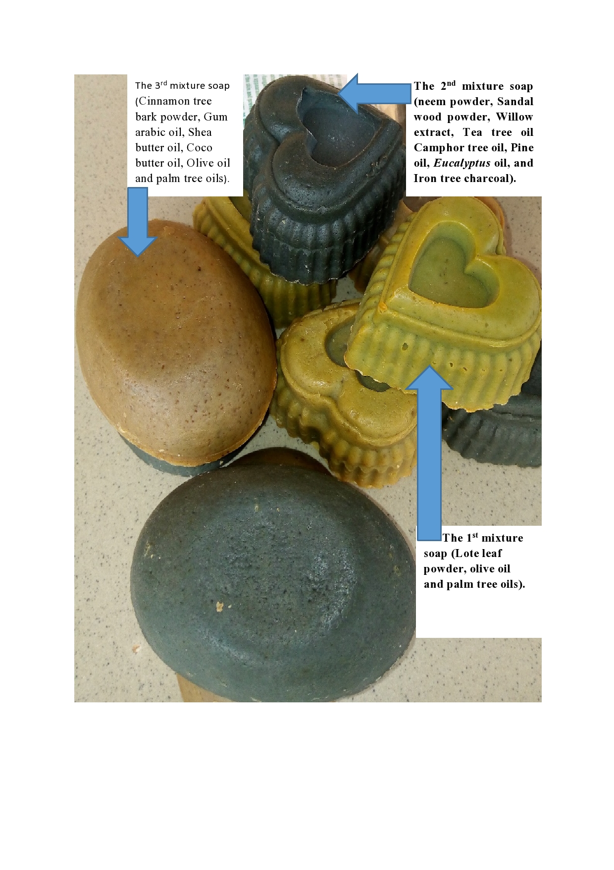
Figure 2: The Soaps Produced from the Forest Tree Extracts
Source: Author’s Work, (2022).
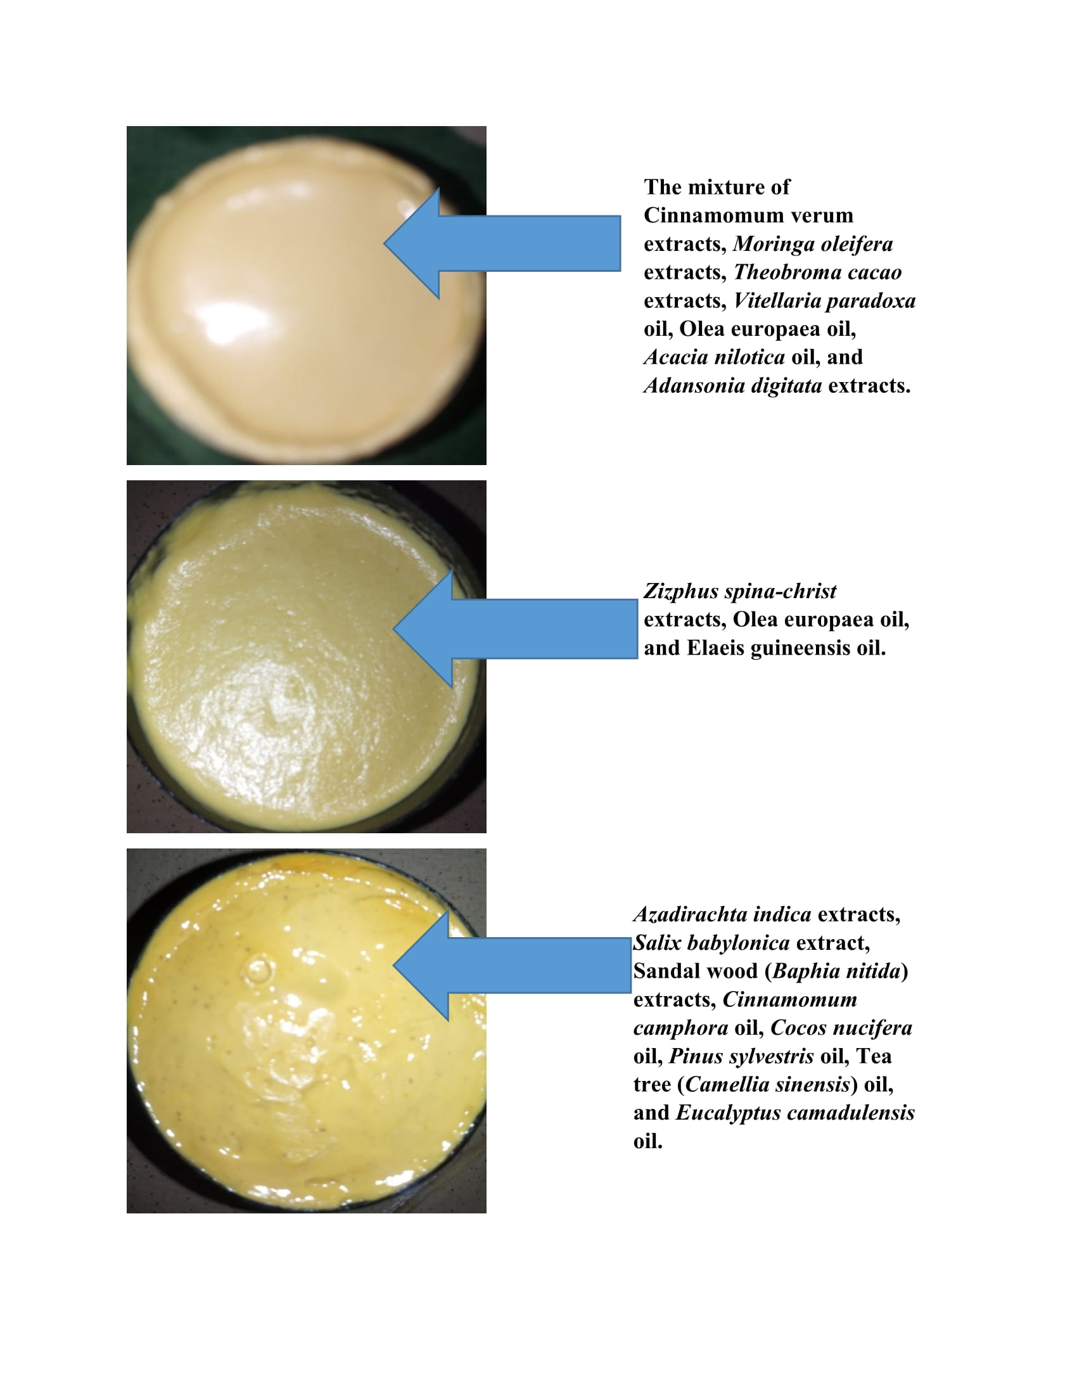
Figure 3: The Creams Produced from Forest Tree Extracts
Source: Author’s Work, (2022)
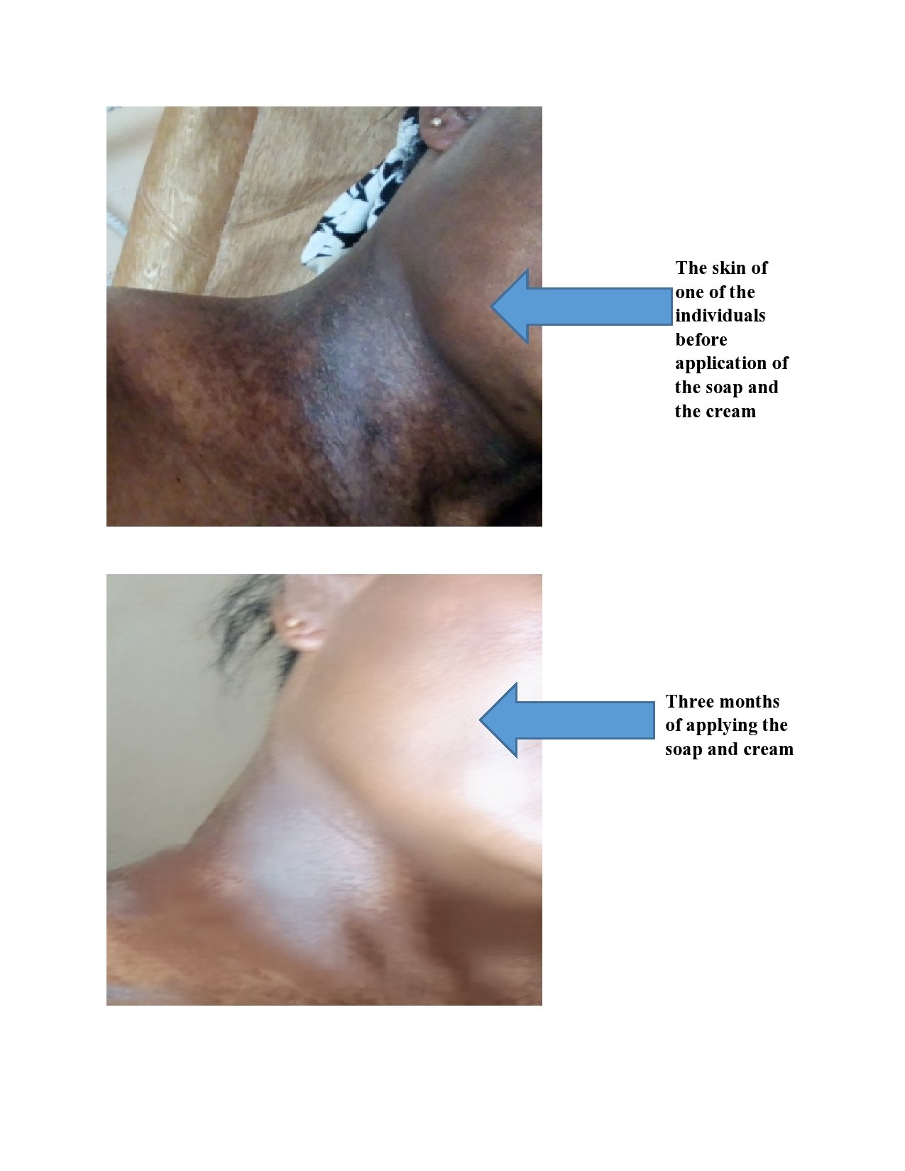
Figure 4: Before and After Application of the Soap and Cream
Source: Author’s Work, (2022).
Photo Credit: Rabi Binta Shuaibu. Permission was granted by the patient to publish the images.
DISCUSSION
In order to create a natural and/or organic formulation, plant derived bioactive compounds from essential oils, cold pressed vegetable oils, natural resins, extracts and other natural; raw materials are combined with plant derived emulsifiers, surfactants, humectants, pigments and other ingredients (Chiu and Kimball, 2003). The tree species chosen for the formulation of this organic soap are well known trees which have been investigated for various activities such as anti-fungal, ant-inflammatory, anti-bacteria, anti-septic, anti-dandruff, anti-viral and antimicrobial activities. Topical formulations have attracted significant interest as a vehicle for drug delivery to the human skin due to easy compliance (Foldvari, 2000). Regular use of this organic soap and cream made from these tree species extracts can fight acne causing bacteria, exfoliate the skin, remove skin blemishes, warts, treat body odour, eczema, and psoriasis, remove suntan, soothe sunburn, and decrease in signs of aging such as dry skin, fine lines, and wrinkles. One strategy against skin aging is the use of topical plant phenolics and antioxidants (Ichihashi et al., 2003). The oils extracted from these trees contributes to the soap hardness, creamy lather, slippery feel, conditioning, moisturizing, attracts external moisture to the skin, and have abilities to improve pigmentation. Aliyu et al. (2012) explained that a traditional medicated soap is produced in Nigeria from a mixture of vegetable oils (palm kernel oil and shea butter) that make the soap to have antimicrobial properties which is recognized in the traditional African households.
The soap and cream produced with the incorporation of Lote Tree (Zizphus spina-christ) extract, Olive Tree (Olea europaea) extracts, and Palm oil tree (Elaeis guineensis) extracts were very active in treating dandruff, lies, sores; shaving bumps, wounds and skin rashes. The leaves of Ziziphus spina-christi are applied locally to sores, and the roots are used to cure and prevent skin diseases (Adzu et al., 2001). From current pharmaceutical studies, additional pharmaceutical applications of Ziziphus spina-christi have revealed antifungal, antibacterial, antinociceptive, antioxidant, antihyperglycemic antidiabetic, antiplasmodial, antischistosomiasis, analgesic and anticonvulsant activities among others (El-Kamali and Mahjoub, 2009; Adzu et al., 2011; Asgarpanah and Haghighat, 2012). Ziziphus spina-christi stem bark aqueous extract has shown highly significant antibacterial effect activity on some Gram negative bacterial growth including Brucella abortus, Brucella melitensis, Proteus spp., Klebsiella spp., P. aeruginosa, E. coli and Enterobacter spp. When compared with eight antibiotics (Korji, 2012).
Olive oil has been widely used in several cosmetic products, such as skin and hair care formulations due to its antioxidant properties. The active compounds responsible for the antioxidant activity, belong to three different classes, including simple phenols, secoiridoids, and lignans (Owen et al., 2000). Also, olive oil may be used to protect the skin from ultraviolet B in the sunlight based on a study reporting that mice receiving olive oil after UVB exposure showed a significantly lower number of developing tumors per mouse than those in the control group receiving nothing (Budiyanto et al., 2000).
The soap and cream produced with the incorporation of Neem tree (Azadirachta indica), Willow tree (Salix babylonica), Camwood tree or African Sandal wood (Baphia nitida), Camphor tree (Cinnamomum camphora), Coconut palm tree (Cocos nucifera), Palm oil tree (Elaeis guineensis), Pine tree (Pinus sylvestris), Tea tree oil (Camellia sinensis), River red gum tree (Eucalyptus camadulensis), and Iron tree (Prosopis africana) extracts were very active in treating skin blemishes, psoriasis, warts, pimples/acne, skin ulcer, and other skin issues. During the past two decades, the biological activity of neem extracts has been investigated intensively, and six international neem conferences have been held covering mainly the application of crude extracts, twigs, stem bark, and root bark, have been shown to possess insect anti-feedant, insecticidal, insect growth disrupting, nematicidal, fungicidal (Warra et al., 2009), bactericidal (Kaur et al., 2005), anti-inflammatory (Schumutterer and Ascher, 1986), anti-worm, immune-stimulating, antiviral, antiseptic, anti-inflammatory, anti-helminthic, anti-malaria, anti-arthritic, anti-ulcer, anti-peptic, antipyretic and anti-libido properties. Its extract has been used in poultice to disperse glandular tumors and ulcer while paste in skin disease like eczema and leprosy and scabies’s (Hassan et al., 2015). Neem oil contains the following fatty acids: oleic acid (25 - 54 %), stearic acid (9 - 24 %), linoleic acid (6 - 16 %), palmitic acid (16 - 33 %), linoleic acid (<1 %) (Kraus, 1995). Sandalwood has been found to have a myriad of different pharmacological effects including anti-inflammatory, anti-oxidant, anti-microbial and anti-proliferative properties (Bhattacharjee and Vinay, 2019). Both Sandal Wood Oil and its active component, alpha-santalol, have also been shown to prevent chemical and UV-induced skin carcinogenesis (Bommareddy et al., 2017). Its anti-inflammatory properties have awakened interest in the treatment of a number of inflammatory skin disorders like psoriasis and atopic dermatitis, possibly as a result of inhibition of phosphodiesterase (Sharma et al., 2018). There are many pharmaceutical applications for camphor such as topical analgesic, antiseptic, antispasmodic, antipruritic, anti-inflammatory, anti-infective, rubefacient, contraceptive, mild expectorant, nasal decongestant, cough suppressant, etc. (Chelliah, 2008). The leaf of Cinnamomum camphora contains camphor,as the main component along with c ineol, linalool, eugenol, limonene, safrole, α­pinene, β­p inene, β­myrecene, α­humulene, p­cymene, nerolidol, borneol, camphene and some other components (Chelliah, 2008). The essential oils from Eucalyptus spp. have proven action against both Gram (+) and Gram (−) bacteria and even antibiotic-resistant Staphylococcus aureus (MRSA) (Tohidpour et al., 2010). This activity is due to the presence in essential oils of aromatic terpenes (Mekonnen et al., 2016), e.g., eugenol, β-pinene, and α-pinene (Medeiros Leite et al., 2007). Camellia sinensis extracts (tea) is a plant producing multiple polyphenols that promote collagen synthesis and have an antiaging effect on the skin (Lee et al., 2014). Soap made with coconut oil tends to be hard, more soluble in hard water and salt water than other soaps allowing it to lather more easily (Ugwuanyi, 2017).
The soap and cream produced with the incorporation of Drum stick tree (Moringa oleifera), Baobab Tree (Adansonia digitata), Coco tree (Theobroma cacao) extracts, Cinnamon tree (Cinnamomum verum), Gum arabic tree (Acacia nilotica), Palm oil tree (Elaeis guineensis), Shea butter tree (Vitellaria paradoxa), and Olive Tree (Olea europaea) extracts were very good in the treatment of dry skin, wrinkles, fine lines, skin infections, acne scars and pigmentation. Moringa oil is rich in essential fatty acids, making it an ideal moisturizer and healing and soothing emollient for rough, dry skin and therapeutic massages. The fatty acids in Moringa oleifera oil are oleic acid (70 %), palmitic acid (7.8 %), behenic acid (6.2 %) and stearic acid (7.6 %) (Abdulkarim et al., 2005). Using a herbal soap containing Cinnamon verum oil reduced acne scars and pigmentation (Atmanto, 2019). Cinnamon verum oil has antibacterial, antimicrobial, and antifungal properties against some bacteria and fungi, including Pseudomonas aeruginosa, Staphylococcus aureus, and Candida albicans (Rao and Gan, 2014). Cinnamon verum contains beta-carotene, vitamin B, eugenol, cinnamaldehyde, coumarin, vitamin A, potassium, polyphenols, cinnamic acid, phosphorus, magnesium, calcium, lycopene, lutein, zeaxanthin, iron, and other nutrients (Shefali et al., 2021). Baobab oil, extracted from the seed, has been used to produce lubricants, soaps and toothpaste, in the topical treatment of various conditions such as muscle spasms, varicose veins and wounds and applied as a moisturizer for skin hydration, for hair and nail conditioning and to treat dandruff (Chindo et al., 2010). Acacia nilotica (Mimosaceae) is a remedial plant recognized to contain abundant phenolics, consisting of condensed tannin and gallic acid, phlobatannin, pyrocatechol, (+) -catechin, protocatechuic acid, (-) epi-gallocatechin-7- gallate and (-) epigallocatechin-5, 7-digallate and others (Ali et al., 2013). Shea butter extract is a complex fat that in addition to many non-saponifiable components contains the following fatty acids: oleic acid (40 - 60 %), stearic acid (20 - 50 %), linoleic acid (3 - 11 %), palmitic acid (2 - 9 %), linolenic acid (<1 %) and arachidic acid (<1 %) (Davrieux et al., 2010). The fatty acid composition palm kernel oil contains lauric acid (48.2 %), myristic acid (16.2 %), palmitic acid (8.4 %), capric acid (3.4 %), stearic acid (2.5 %), oleic acid (15.3 %), linoleic acid (2.3 %) and others (0.4 %) (Ugwuanyi, 2017).
Conclusion
Extracts of a wide variety of forest trees are non-toxic and hypoallergenic, they are natural antioxidants, anti-ageing, anti-inflammatory, anti-septic, anti-microbial, anti-fungal, anti-bacteria, anti-viral, anti-parasitic, as a sunscreen, and stimulate the production of collagen. This study have shown that Forest tree extracts are better and stronger alternative to the dangerous chemicals such as hydroquinone, mercury, lead, and arsenic which do more harms than good to the skin. There is therefore big opportunities for Nigeria to expand its cosmetic industries using her unique abundance of forest tree species extracts and re planting more of the forest tree species needed for the sustainability of the organic products.
Recommendations
More research is recommended in the healing and spiritual power of Zizphus spina-christ and Olea europaea extracts
Conflict of Interest: The authors declare that they have no conflict of interest.
Funding: This research did not receive any specific grant from funding agencies in the public, commercial, or not-for-profit sectors.

References

Abdulkarim S M, Lai O M, Muhammad S K S, Long K, Ghazali H M. 2005. Some Physico-Chemical Properties of Moringa oleifera Seed Oil Extracted using Solvent and Aqueous Enzymatic Methods. Food Chem. 93, 253-263.

Aburjai T, Natsheh F M, 2003. Plants Used in Cosmetics. Phytother. Res. 17. Pp 987–1000 Published online in Wiley Inter Science.

Adzu B, Amos S, Wambebe C, Gamaniel K, 2001. Ant-nociceptive Activity of Ziziphus spina christi root bark extract. Fitoterapia 72:334350.

Adzu B, Haruna AK, Ilyas M, Pateh UU, Tarfa FD, Chindo BA, Gamaniel K, 2011. Structural Characterization of ZS – 2A: An Anti-plasmodia Compound Isolated from Zizyphus spina-christi Root Bark. J. Pharm. Nut. Sci. 1:48-53.

Ali A, Akhtar N, Khan MS. 2013. Enhancement of Human Cheek Skin Texture by Acacia nilotica Bark Extract Cream Tropical Journal of Pharmaceutical Research. 12 (3): 323-327

Aliyu, MS., Tijjani, MB., Doko, MHI, Garba I, Ibrahim MM, Abdulkadir SM, Abba D, Zango, UU 2012. Antimicrobial Activity of Sabulun Salo a Local Traditional Medicated Soap. Nigerian J. Basic Appl. Sci. 20(1):35-38.

Asgarpanah J, Haghighat E. 2012. Phytochemistry and pharmacologic Properties of Ziziphus spina christi (L.) Willd. African Journal of Pharmacy and Pharmacology Vol. 6(31). Pp. 2332-2339. DOI: 10.5897/AJPP12.509 ISSN 1996-0816

Atmanto D. (2019): Influence of the Addition of the Essential Oil of Cinnamon (Cinnamomum burmanii) in Soap against Skin Care. KnE Social Sciences, 3(12), 587–595.

Bhattacharjee R, Vinay K 2019. Re-Discovering Sandalwood: Beyond Beauty and Fragrance. Indian Dermatol Online Journal; 10(3): 296–297. doi: 10.4103/idoj.IDOJ_357_18

Bommareddy A, Brozena S, Steigerwalt J, Landis T, Hughes S, and Mabry E, et al. (2017): Medicinal Properties of Alpha-Santalol, a Naturally Occurring Constituent of Sandalwood Oil: Review. Nat Prod Res. 1–17.

Budiyanto A., Ahmed N.U., Wu A., et al. (2000): Protective Effect of Topically Applied Olive Oil against Photo carcinogenesis following UVB Exposure of Mice. Carcinogenesis 21: 2085–2090.

Caesar F.C.S., Carnevale Neto F., Porto G.S., Campos P.M.B.G.M. 2017. Patent Analysis: A Look at the Innovative Nature of Plant-Based Cosmetics. Quim. Nova. 40:840 – 847.

Chelliah AD, 2008. Biological Activity Prediction of an Ethno Medicinal Plant Cinnamomum Camphora through Bioinformaticts. Ethnobotanical Leaflets 12:18 190

Chindo, I.Y., Gushit, J.S., Olotu, P.N., Mugana, J., Takbal, D.N. (2010): Comparison of the Quality Parameters of the Seed and Condiment Oil of Adansonia digitata. J. Am. Sci. 6, 990-994

Chiu A, Kimball AB, 2003. Topical Vitamins, Minerals and Botanical Ingredients as Modulators of Environmental and Chronological Skin Damage. Br J Dermatol. 149(4):681–691.

Dweck AC, 1996. Botanicals Research of Actives. Cosmet Toiletries 111: 45–57.

El-Kamali HH, Mahjoub SA, (2009): Antibacterial Activity of Francoeuria crispa, Pulicaria undulata, Ziziphus spina-christi and Cucurbita pepo against Seven Standard Pathogenic Bacteria. Ethnobot. Leaflets 13:722-733.

Foldvari M, 2000. Non-invasive administration of drugs through the skin: challenges in delivery system design. Pharm Sci Technol To. 3: 417-425

França K, França A P, De França R. 2017, Environmental Psychodermatology: Stress, Environment and Skin. In: França K., Jafferany M., editors. Stress and Skin Disorders: Basic and Clinical Aspects. Cham. Springer International Publishing. Pp 47–53.

Francisco J G , Luis B, 2018. The Use of Plants in Skin-Care Products, Cosmetics and Fragrances: Past and Present. Cosmetics, 5, 50; Doi: 10.3390/cosmetics5030050

González, S.; Fernández-Lorente, M.; Gilaberte-Calzada, Y. 2008. The Latest on Skin Photo Protection. Clin. Dermatol. 26, 614–626.

Greta Faccio 2020. Plant Complexity and Cosmetic Innovation. iScience. Vol. 23(8): 101358. Published online 2020 Jul 10. Doi: 10.1016/j.isci.2020.101358

Hassan K J, Zubairu MS, Olayemi OR 2015, Production of Soap from Neem Seed Oil and Acacia nilotica Seed Oil. International Journal of Modern Organic Chemistry, 4(1): 70-84

Ichihashi M M, Ueda A, Budiyanto T, Bito M, Oka M, Fukunaga K, Tsuru TH. 2003. UV-induced skin damage. Toxicol 189: 21-39.

Kaur K, Michael H, Arora S, 2005. In Vitro Bioactivity-Guided Fractionation and Characterization of Polyphenolic Inhibitory Fractions from Acacia nilotica (L.) Willd. ex Del. J. Ethnopharmacol. 99: 353-360.

Korji SHA 2012. Inhibition of Nitrate Reductase Production from Gramnegative Bacteria using Ziziphus spina-christi Extract and Comparing with some Antibiotics. Iraqi J. Agric. Sci. 43(2):144-150

Kraus, 1995. "Biologically Active Ingredients-Azadirachtin and other Triterpenoids", in: H. Schutterer (Ed.), the Neem Tree Azadirachta indica A. Juss and other Meliaceous Plants, Weinheim, New York, 1995, p 35-88

Lee K O, Kim SN, Kim YC, (2014): Anti-Wrinkle Effects of Water Extracts of Teas in Hairless Mouse. Toxicol. Res. 30:283–289.

Mahmoudi S, Mancini E, Xu L., Moore A., Jahanbani F., Hebestreit K., Srinivasan R., Li X., Devarajan K., Pralot L. (2019): Heterogeneity in Old Fibroblasts is Linked to Variability in Reprogramming and Wound Healing. Nature. 574:553–558.

Medeiros LA, De Oliveira LE, De Souza EL, De Fátima F, Melo Diniz M, Nogueira TV, Almeida De Medeirosi I. 2007. Inhibitory Effect of B-pinene, A-pinene and Eugenol on the Growth of Potential Infectious Endocarditis causing Gram-positive Bacteria. Rev. Bras. Cienc. Farm. 43:121–126.

Mekonnen A, Yitayew B, Tesema A, Taddese S, 2016. In Vitro Antimicrobial Activity of Essential Oil of Thymus schimperi, Matricaria chamomilla, Eucalyptus globulus, and osmarinus officinalis. Int. J. Microbiol. 2016; 2016:9545693.

Momeni F, Ni J, 2018. Nature-inspired smart solar concentrators by 4D printing. Renew. Energy. 122:35–4Michalak M. (2022): Plant-Derived Antioxidants: Significance in Skin Health and the Ageing Process. Int J Mol Sci. 6; 23(2): 585. Doi: 10.3390/ijms23020585. PMID: 35054770; PMCID: PMC8776015.

Owen RW, Giacosa A, Hull WE 2000. Olive-Oil Consumption and Health: The Possible Role of Antioxidants. Lancet Oncol 1: 107–112. DOI: 10.1016/S1470-2045(00)00015-2

Rao P V, Gan S H, 2014. Cinnamon: a Multifaceted Medicinal Plant. Evidence-Based Complementary and Alternative Medicine. Volume 2014, Article ID 642942, 12 pages

Schumutterer H, 1986. Natural Pesticides from the Neem Tree and other Tropical Plants. Proc. 3rd Int. Neem Conf., Nairobi, Kenya. Pp. 2-4.

Sharma M, Levenson C, Browning JC, Becker EM, Clements I, Castella P, et al. 2018. East Indian sandalwood oil is a phosphodiesterase inhibitor: A new therapeutic option in the treatment of inflammatory skin disease. Front Pharmacology. 9:200.

Shefali A, Mahak G, Ravi G, Rohit K, Pushpendu S, Deepak K, 2021. Cinnamon: a Clinical Approach as Multifarious Natural Remedy with Absolute Immunity. European Journal of Molecular and Clinical Medicine Volume 08, Issue 03. Pp 2331 – 2345 ISSN 2515-8260

Tiku AR, 2020. Antimicrobial Compounds (Phytoanticipins and Phytoalexins) and their Role in Plant Defense. In: Mérillon J., Ramawat K.G., editors. Co-Evolution of Secondary Metabolites. Springer International Publishing. Pp. 845–868.

Tohidpour A, Sattari M, Omidbaigi R, Yadegar A, Nazemi J, 2010. Antibacterial Effect of Essential Oils from Two Medicinal Plants against Methicillin-Resistant Staphylococcus aureus (MRSA) Phytomedicine. 17:142–145.

Ugwuanyi E D. 2017. Production of Antimicrobial Soap using a Blend of Moringa oleifera Oil and Ricinus communis (Castor Oil). A Dissertation Submitted To the School of Posgraduate Studies, Ahmadu Bello University, Zaria In Partial Fulfillment of the Requirements for the Award of a Master of Science Degree in Chemical Engineering.

Ugwuanyi ED, 2017. Production of Antimicrobial Soap using a Blend of Moringa Oleifera Oil and Ricinus Communis (Castor Oil). A Dissertation Submitted To the School of Postgraduate Studies, Ahmadu Bello University, Zaria In Partial Fulfillment of the Requirements for the Award of a Master of Science Degree in Chemical Engineering

United Nations, 2020. Overall Total Population of Nigeria from the Yearly Population Growth Rate Chart Plots. The Annual Percentage Changes in Population Registered on July 1. Department of Economic and Social Affairs, Population Division.

Warra A A, Gunu S A, Aisha J A, 2009. Soap Production from Shea Nut Butter. Int. J. Appl. Sci. 5: 410-412.

Wu G, Ruben MD, Schmidt RE, Francey LJ, Smith DF, Anafi RC, Hughey JJ, Tasseff R., Sherrill JD, Oblong JE 2018. Population-Level Rhythms in Human Skin with Implications for Circadian Medicine. Proc. Natl. Acad. Sci. U S A. 115:12313.

